# 

Employee

management

Java application

Technical document

1. Introduction to Employee Management App 3

Purpose and Scope: 3

Efficiency and Productivity: 3

Data Integrity and Security: 3

Accessibility and Scalability: 3

Compliance and Reporting: 4

2. MySQL Series and PreparedStatement integration 4

1. MySQL Series Enhancement: 4

2. Field Addition Process: 4

3. PreparedStatement Implementation: 5

4. Parameterized Queries: 5

5. Efficient Database Interactions: 5

3. Access Database Enhancement 6

1. Integration of Phone Number Field: 6

2. Expanded Data Capture: 6

3. Field Addition Process: 6

4. Data Migration Considerations: 6

5. Impact on Application Functionality: 7

4. EmployeeManagementApp Class Overview 7

1. Graphical User Interface (GUI): 7

2. Database Interaction: 7

3. Model-View-Controller (MVC) Architecture: 8

4. Event Handling and Error Management: 8

5. Graphical User Interface (GUI) Design 9

1. User-Friendly Layout: 9

2. Consistent Styling and Theming: 9

3. Responsive Design: 10

4. Intuitive Navigation: 10

5. Accessibility and Inclusivity: 10

6. Event Handling Mechanisms 10

1. Event Registration and Listener Setup: 10

2. Action Response Mapping: 11

3. Asynchronous Event Handling: 11

4. Error Handling and Validation: 12

5. Event Propagation and Bubbling: 12

7. Exception Handling Strategies 12

1. Robust Exception Catching: 12

2. Granular Exception Types: 12

3. Custom Exception Classes: 13

4. Logging and Reporting: 13

5. User-Friendly Error Messages: 13

8. fetchData Method Implementation 13

1. Connection Establishment: 13

2. SQL Query Construction: 14

3. Query Execution: 14

4. Data Retrieval and Parsing: 15

5. Data Population: 15

9. showAlert Method Utilization 15

1. Alert Creation: 15

2. Message Customization: 15

3. Error Handling: 15

4. User Interaction: 15

5. Informative Feedback: 16

10. ViewFrame Class Overview 16

1. Graphical User Interface (GUI) Components: 16

2. Input Field for Employee ID: 16

3. Search Functionality: 16

4. Text Area for Displaying Employee Information: 17

5. Error Handling and Feedback: 17

# 

# 

# 1. Introduction to Employee Management App

## Purpose and Scope:

The Employee Management App is a comprehensive software solution designed to centralize and automate the management of employee records within an organization. It aims to streamline HR processes by providing a user-friendly interface for storing, retrieving, and updating employee information.

## Efficiency and Productivity:

By digitizing employee records and leveraging modern technologies such as JavaFX and JDBC, the application enhances the efficiency of HR operations. It eliminates manual paperwork, reduces administrative overhead, and enables HR professionals to focus on strategic tasks rather than mundane record-keeping.

## Data Integrity and Security:

The app prioritizes data integrity and security by implementing robust authentication mechanisms and access controls. It ensures that only authorized personnel can access and modify employee data, safeguarding sensitive information from unauthorized access or tampering.

## Accessibility and Scalability:

With its web-based architecture and cloud-ready design, the Employee Management App offers accessibility across multiple devices and locations. Whether accessed from desktops, laptops, or mobile devices, users can securely access employee records anytime, anywhere. Additionally, the application is designed to scale seamlessly as the organization grows, accommodating an increasing volume of employee data without compromising performance.

## Compliance and Reporting:

The application facilitates compliance with regulatory requirements and internal policies by maintaining accurate and up-to-date employee records. It enables HR managers to generate customizable reports and analytics, providing valuable insights into workforce demographics, performance metrics, and trends. This supports informed decision-making and strategic workforce planning initiatives within the organization.

# 2. MySQL Series and PreparedStatement integration

## MySQL Series Enhancement:

The Employee Management App extends the existing MySQL series by incorporating two additional fields to accommodate new data requirements. This expansion enhances the versatility and scalability of the database schema, enabling it to store a broader range of employee-related information.

## Field Addition Process:

The integration process involves modifying the structure of the MySQL database to include the new fields seamlessly. This includes defining the data types, constraints, and relationships necessary to maintain data integrity and consistency.

## PreparedStatement Implementation:

The application adopts PreparedStatement, a feature of JDBC (Java Database Connectivity), to execute parameterized SQL queries against the MySQL database. PreparedStatement offers significant advantages over traditional Statement objects, such as improved performance, security, and prevention of SQL injection attacks.

## Parameterized Queries:

PreparedStatement allows developers to create SQL queries with placeholders for parameters, which are later substituted with actual values at runtime. This approach mitigates the risk of SQL injection attacks by automatically escaping special characters and ensuring proper data validation and sanitization.

## Efficient Database Interactions:

By utilizing PreparedStatement, the Employee Management App optimizes database interactions by precompiling SQL statements and reusing execution plans. This results in improved performance and reduced overhead, especially in scenarios involving repetitive queries or batch operations. Additionally, PreparedStatement enhances code readability and maintainability by separating SQL logic from parameter values

# 3. Access Database Enhancement

## 1. Integration of Phone Number Field:

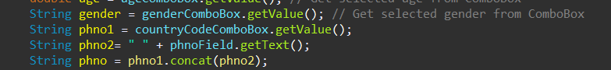

The Access Database undergoes enhancement through the addition of a phone number field to accommodate the growing need for comprehensive employee records. This augmentation reflects the evolving nature of employee data management, catering to modern communication requirements.

## 2. Expanded Data Capture:

With the inclusion of the phone number field, the Access Database becomes capable of capturing additional contact information, enabling more effective communication and coordination between employees and stakeholders. This expansion aligns with best practices in HR management, facilitating seamless interaction within the organizational ecosystem.

## 3. Field Addition Process:

The enhancement process involves modifying the database schema within Microsoft Access to incorporate the new phone number field. This entails defining the appropriate data type, format constraints, and indexing options to ensure data consistency and query performance.

## 4. Data Migration Considerations:

When introducing new fields to an existing database schema, careful consideration is given to data migration strategies to preserve the integrity and continuity of existing records. Depending on the volume of data and database architecture, migration methods such as SQL scripts or import/export utilities may be employed to transfer data seamlessly while minimizing downtime and disruption.

## 5. Impact on Application Functionality:

The addition of the phone number field necessitates corresponding updates to the application's user interface and data processing logic to accommodate the new data element. This includes modifying data entry forms, validation rules, and query parameters to incorporate the phone number field effectively into the application workflow. Additionally, user training and documentation updates may be required to inform stakeholders of the enhanced functionality and data capture capabilities.

# 4. EmployeeManagementApp Class Overview

## 1. Graphical User Interface (GUI):

The EmployeeManagementApp class boasts a sophisticated GUI designed using JavaFX, offering users a modern and intuitive interface for interacting with employee data. Components such as TableView, buttons, and text fields are strategically organized within the primary stage to optimize user experience and streamline navigation.

## 2. Database Interaction:

Leveraging JDBC (Java Database Connectivity), the EmployeeManagementApp class orchestrates seamless communication with the underlying database, facilitating operations such as data retrieval, searching, and updating. Through structured SQL queries and PreparedStatement integration, the class ensures efficient data manipulation while adhering to best practices in database management.

## 3. Model-View-Controller (MVC) Architecture:

The class embodies the MVC architectural pattern, dividing responsibilities into distinct modules for managing user interactions (View), data retrieval and manipulation (Model), and application logic (Controller). This architectural approach promotes code modularity, scalability, and maintainability, allowing for easier debugging and future enhancements.

## 4. Event Handling and Error Management:

Robust event handling mechanisms are implemented to capture user interactions and trigger appropriate actions within the application. Additionally, comprehensive error handling strategies are employed to gracefully manage exceptions that may occur during database operations, ensuring a seamless user experience and preventing unexpected application crashes or data inconsistencies.

# 5. Graphical User Interface (GUI) Design

## 1. User-Friendly Layout:

The GUI design prioritizes user-friendliness by employing a clean and intuitive layout. Components such as buttons, input fields, and data displays are strategically placed to minimize cognitive load and streamline user interactions. This design choice enhances usability and ensures that users can navigate the application effortlessly.

## 2. Consistent Styling and Theming:

A consistent styling and theming approach is adopted throughout the GUI to provide a cohesive visual experience. Colors, fonts, and graphical elements are chosen thoughtfully to maintain visual harmony and reinforce brand identity. This consistency contributes to a polished and professional appearance, instilling confidence in users and fostering trust in the application.

## 3. Responsive Design:

The GUI design is responsive, adapting dynamically to different screen sizes and resolutions. Flexible layouts and adaptive components ensure that the application remains functional and visually appealing across a wide range of devices, including desktop computers, laptops, tablets, and smartphones. This responsiveness enhances accessibility and accommodates diverse user preferences and usage scenarios.

## 4. Intuitive Navigation:

Navigation within the GUI is designed to be intuitive and logical, guiding users seamlessly through different sections and functionalities of the application. Clear labeling, descriptive icons, and hierarchical organization aid users in understanding the application's structure and finding relevant features efficiently. This intuitive navigation reduces cognitive friction and empowers users to accomplish their tasks with minimal effort.

## 5. Accessibility and Inclusivity:

The GUI design prioritizes accessibility and inclusivity, ensuring that all users, including those with disabilities or special needs, can interact with the application comfortably and effectively. Accessibility features such as keyboard navigation, screen reader compatibility, and high contrast modes are implemented to accommodate diverse user needs and comply with accessibility standards and guidelines. This commitment to inclusivity reflects the application's dedication to serving a broad and diverse user base.

# 6. Event Handling Mechanisms

## 1. Event Registration and Listener Setup:

The event handling mechanisms in the GUI are based on registering event listeners for specific user actions. Components such as buttons, input fields, and menus are equipped with event listeners that detect user interactions such as clicks, keystrokes, or selections.

## 2. Action Response Mapping:

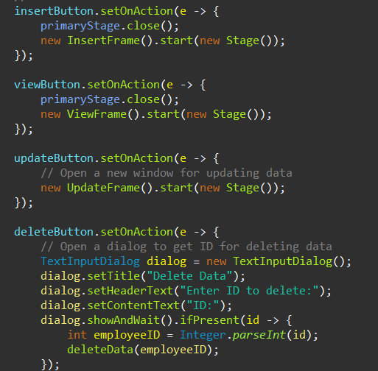

Each registered event listener is associated with a corresponding action or method invocation. When a user triggers an event, the associated action is executed, leading to the desired behavior or response in the application. This mapping ensures that user interactions are translated into meaningful actions within the application's context.

## 3. Asynchronous Event Handling:

Asynchronous event handling is employed to maintain responsiveness and prevent blocking the user interface during lengthy or resource-intensive operations. Long-running tasks such as database queries or network requests are executed asynchronously, allowing the GUI to remain interactive and responsive to user input.

## 4. Error Handling and Validation:



Event handling mechanisms include robust error handling and input validation procedures to ensure data integrity and application stability. Input from users is validated against predefined criteria or constraints, and appropriate error messages are displayed if validation fails. Error handling routines gracefully manage unexpected scenarios, providing informative feedback to users and guiding them on corrective actions.

## 5. Event Propagation and Bubbling:

The GUI framework facilitates event propagation and bubbling, allowing events to be captured and processed by multiple layers of the application's component hierarchy. This enables flexible event routing and delegation, empowering developers to implement complex interaction patterns and modularize event handling logic effectively.

# 7. Exception Handling Strategies

## 1. Robust Exception Catching:

The application employs a robust exception handling strategy to catch and manage exceptions that may occur during runtime. This includes using try-catch blocks to encapsulate code sections where exceptions are likely to occur, enabling graceful recovery or termination of the affected operations.

## 2. Granular Exception Types:

Exception handling is implemented with granularity, distinguishing between different types of exceptions based on their nature and severity. This allows for targeted handling of specific error conditions, ensuring appropriate actions are taken depending on the underlying cause of the exception.

## 3. Custom Exception Classes:

Custom exception classes are utilized to encapsulate application-specific error scenarios, providing meaningful context and information about the encountered problems. By defining custom exception classes, the application can convey detailed error messages and metadata to facilitate debugging and troubleshooting.

## 4. Logging and Reporting:

Exception handling includes logging mechanisms to record details about encountered errors, such as stack traces, timestamps, and contextual information. Logged exceptions are reported to designated logging frameworks or systems, enabling developers and administrators to monitor application health and diagnose issues proactively.

## 5. User-Friendly Error Messages:

In addition to logging exceptions for internal debugging purposes, the application presents user-friendly error messages to inform users about encountered problems and guide them on potential solutions. Error messages are designed to be clear, concise, and actionable, helping users understand the nature of the issue and take appropriate corrective actions.

# 8. fetchData Method Implementation

## 1. Connection Establishment:

The fetchData method initiates by establishing a connection to the MySQL database using JDBC (Java Database Connectivity). This connection is pivotal for executing SQL queries and retrieving data from the underlying database tables.

## 2. SQL Query Construction:

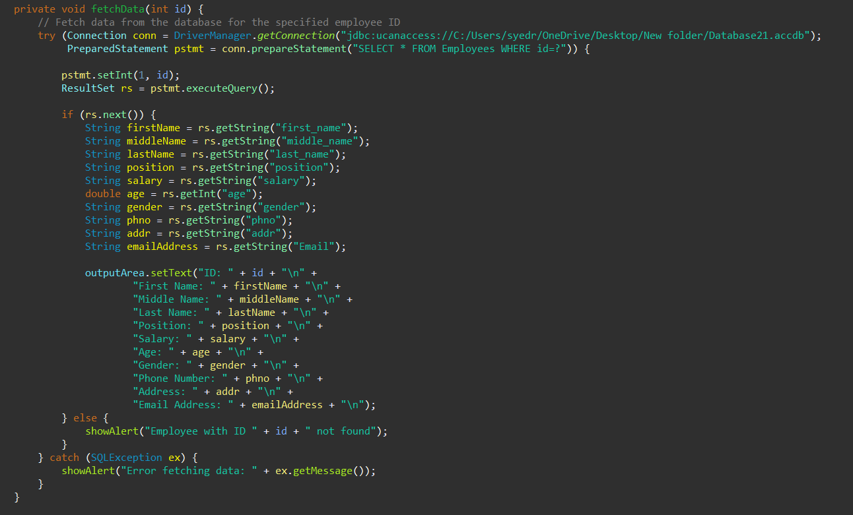

Once the database connection is established, the method constructs a parameterized SQL query tailored to retrieve employee records based on the provided employee ID. Parameterization is crucial for dynamic data retrieval and prevents SQL injection attacks by sanitizing user input.

## 3. Query Execution:

After constructing the SQL query, the method proceeds to execute it against the MySQL database. This step involves utilizing PreparedStatement to securely bind parameters and prevent SQL injection vulnerabilities.

## 4. Data Retrieval and Parsing:

Upon successful execution of the SQL query, the method retrieves the resulting dataset containing employee records matching the specified employee ID. The retrieved data is parsed from the ResultSet object obtained from the database query execution.

## 5. Data Population:

Once the data is parsed, the method populates the application's user interface components, such as a TableView or text area, with the fetched employee records. This step ensures that users can visualize the retrieved data conveniently within the application's interface.

# 9. showAlert Method Utilization

## 1. Alert Creation:

The showAlert method facilitates the creation of alert dialogs using JavaFX's Alert class. These dialogs serve various purposes such as displaying informational messages, warnings, or errors to the user based on specific scenarios encountered during application execution.

## 2. Message Customization:

This method allows for the customization of alert messages by accepting parameters such as title, message content, and alert type. Developers can tailor the alert messages dynamically based on the context in which the showAlert method is invoked, ensuring relevance and clarity.

## 3. Error Handling:

One of the primary use cases of the showAlert method is error handling. In the event of unexpected errors or exceptions occurring during application execution, the method is invoked to present error messages to the user via alert dialogs. These messages provide valuable feedback and guidance on how to resolve or mitigate the encountered issues.

## 4. User Interaction:

Alert dialogs generated by the showAlert method are presented to the user in a modal fashion, temporarily halting the application's execution until the dialog is acknowledged. This ensures that users are prompted to take necessary actions or acknowledge important messages before proceeding further, preventing unintended interactions or misunderstandings.

## 5. Informative Feedback:

By displaying alert dialogs with relevant messages, the showAlert method enhances the overall user experience by providing informative feedback. Whether it's notifying users about successful operations, warning them about potential risks, or guiding them through error resolution steps, these alerts play a crucial role in facilitating effective communication between the application and its users.

# 10. ViewFrame Class Overview

## 1. Graphical User Interface (GUI) Components:

The ViewFrame class encapsulates a graphical user interface (GUI) designed using JavaFX, comprising input fields, buttons, and text areas. These components are strategically organized to provide users with an intuitive and streamlined interface for viewing employee records.

## 2. Input Field for Employee ID:

A key feature of the ViewFrame GUI is the provision of an input field where users can enter the employee ID they wish to search for. This input mechanism enables users to specify the target employee whose information they want to view.

## 3. Search Functionality:

The ViewFrame class implements search functionality through a dedicated button that users can click to initiate the retrieval of employee data from the database. This feature empowers users to quickly and efficiently access the desired information without manual database querying.

## 4. Text Area for Displaying Employee Information:

Upon successful retrieval of employee data, the ViewFrame class populates a text area within the GUI with the detailed information of the selected employee. This text area is designed to present the data in a structured and readable format, enhancing user comprehension and usability.

## 5. Error Handling and Feedback:

In addition to its primary functionalities, the ViewFrame class incorporates robust error handling mechanisms to manage various scenarios such as invalid input or database connection issues. Error messages are displayed to users via alert dialogs, providing informative feedback and guiding them on corrective actions to ensure a smooth user experience.